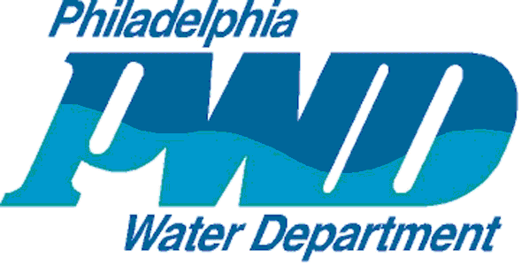
PHILADELPHIA WATER DEPARTMENT

DESIGN BRANCH

Final Design Package

Checklist

Note: This form must accompany final design package.

PWD Work Number and Project Description: | Date:
Information required for final submittal | Provided
 | Yes | No | N/A
- Memo or e-mail from Design Supervisor approving final plans & specs
- 1 set of mylar drawings (signed & rolled)
- 1 copy of PGW response letter
- 1 copy of Philadelphia Streets Department paving letter
- GPIS forms completed on web application, see PWD Project Engineer for procedure
Electronic Submittals on CD or DVD:
- Specifications in Microsoft Word format
- Design Drawings in AutoCAD or Micro-Station format
- Design Drawings in PDF format
- Engineer’s Estimate of Construction Cost and PWD’s Water, Sewer, and Green Quantities Spreadsheets (as needed) in Microsoft Excel format
- 1 copy of each utility response letter in PDF format
- PWD GSI Design Report as a single PDF. Additionally, supporting files in the formats below shall be provided as separate attachments
  - Written Report documenting design approach and assumptions (.PDF)
  - GreenIT Data Entry Application Metrics Report (.CSV, .PDF)
  - “Shared” GreenIT Data Entry Application Project(s) with PWD Project Engineer
  - Supporting design calculations and modeling files (XLSX and modeling original files)
  - Drainage area maps (.PDF and .DWG)
- Approved Roadway Grading Plans in PDF format
- Approved Curb Ramp Designs in PDF format
- Quantities Certification in PDF format
- Project Summary in Microsoft Word and PDF format

Appendix IIIf: Final Design Package Checklist - Page 1 of 1

