Dear PWD Customer, Property Owner, and/or Current Occupant,

This is the first in a series of letters to let you know that the Philadelphia Water Department (PWD) is **planning a construction project** in a green space in your neighborhood. This work is anticipated to start in 3-9 months. More information is below and on the PWD Project Page.

This ecological restoration project is being done in coordination with Philadelphia Parks and Recreation (PPR), Friends of Mount Moriah Cemetery (FOMMC), Yeadon Borough, and will occur on the banks of Cobb Creek, entirely within Mount Moriah Cemetery (see page 2 map).

The work will protect critical PWD sewer infrastructure, reduce stream bank and streambed erosion, and improve the aquatic habitat of Cobbs Creek. For more info on our Ecological Restoration (ER) Unit’s work, please visit: [water.phila.gov/sustainability/ecorestoration/](https://water.phila.gov/sustainability/ecorestoration/)

As part of this project, called **Mount Moriah Streambank & Cobbs Creek Interceptor Stabilization (PWD Project #50228),** our contractor will conduct the following work on-site:

* Repairing critical structural elements of exposed sewer segments & manholes
* Repairing 1,200 feet of stream bank (stabilization, modification & enhancement), erosion protection, and improved stream habitat south of the Cobbs Creek Parkway bridge
* Reconstruction of a stormwater outfall
* Planting of 230+ trees, 100 shrubs, and 3,000+ native ‘live stakes’ for ecosystem uplift upon project completion

To find out more details about this ER project, please scan the QR code (below), see the map on page 2, and visit: [**water.phila.gov/projects/p50228/**](http://water.phila.gov/projects/p50228/)

Our construction team will require the use of heavy equipment (including excavators, bulldozers, dump trucks, etc) and access the site along Cobbs Creek Parkway in two locations: 1) mainly at the Mount Moriah Cemetery driveway (2609 Cobbs Creek Parkway), and 2) near the first bridge (5195 Cobbs Creek Parkway). PWD’s contractor will be responsible for traffic flow and control in/out of the site, prevention of construction debris from getting into the creek (erosion & sediment control), and for scheduling material delivery to/from during normal construction working hours. PWD will also have an inspector assigned to this project.

The contractor assigned to this job is AP Construction. **Construction is expected to begin in approximately 3-9 months**. However, please note that this is an estimate, and the construction start date can be earlier or later than the anticipated timeline.

A follow-up letter will be sent closer to the time of construction. Please reach out to both myself and Amy Hopf, our Construction Outreach Specialist (Amy.Hopf@phila.gov), with any questions.

(Page 1; turn over)

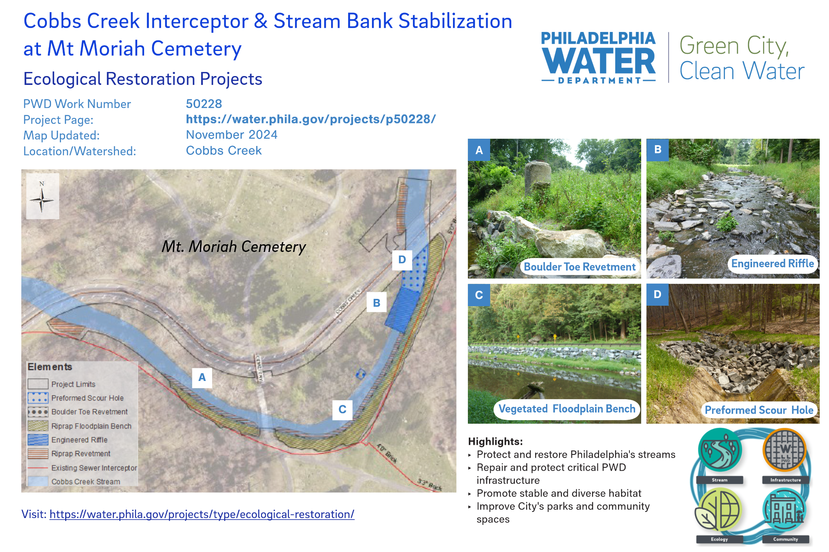

Lastly, if you want to receive email notifications from PWD, please visit water.phila.gov/signup to register. 

Sincerely,

Rick Howley

PWD ER Supervisor, GSSD Unit

1101 Market Street, 4th Floor

Phila PA 19107

[Rick.Howley@phila.gov](mailto:Rick.Howley@phila.gov)

O | (215) 685-6034

If you need a copy of this information in another language, please call the number above.

Si desea una copia de esta información en español, llámenos al número indicado arriba.

Nếu quý vị muốn có một bản sao thông tin này bằng tiếng Việt, hãy gọi chúng tôi theo số máy trên đây.

假如您希望獲取該資訊的華語譯本，請撥打我們上面的電話號碼。

이 안내문의 한국어 본을 원하시면, 위에 제시된 번호로 저희에게 전화하여 주십시오.

Если Вы хотите получить данную информацию на русском языке, пожалуйста, звоните нам по указанному выше номеру телефона.